Kubernetes Task-2

Task Description:

Create the K8s EKS,further you have to do the deployment of the Nginx application and access the application outside the cluster.

Step 1:

Install ASWCLI, eksctl, kubectl

Step 2: Configure AWS

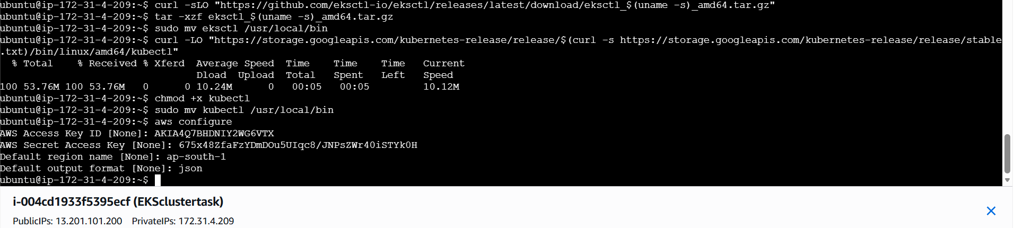

Step 3:
Create EKS cluster
eksctl create cluster \
--name my-eks-cluster \
--region ap-south-1 \
--nodegroup-name linux-nodes \
--node-type t3.medium \
--nodes 2 \
--nodes-min 1 \
--nodes-max 3

Step 4:
Create ngnix yaml for deployment
apiVersion: apps/v1
kind: Deployment
metadata:
name: nginx-deployment
spec:
replicas: 2
selector:
matchLabels:
app: nginx
template:
metadata:
labels:
app: nginx
spec:
containers:
- name: nginx
image: nginx:latest
ports:
- containerPort: 80
---
apiVersion: v1
kind: Service
metadata:
name: nginx-service
spec:
type: LoadBalancer
selector:
app: nginx
ports:
- port: 80
targetPort: 80
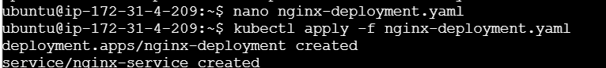

Step 5:

Step 6: Load balancer url

